Project Plan for Web Programming II

# Team Members:

|  |  |
| --- | --- |
| Name | ID |
| Mandeep Singh | C0758002 |

# Description of the project:

|  |
| --- |
| Air India  Website is based on aviation Air India. Home page will allow to explore through every other page and consist of animation using keyframes in CSS in homepage.  Booking page will help to book fight by filling out details. If you are choosing one way it will disable the return input box. You must fill every other filed that is required. Manage your flight page will help to find you fight schedules and to choose what you would like to eat in flight.  Special offer page consists of all the information you need to get offers while travelling. Baggage page consist of all the information regarding products allowance, weight allowance and other information .Contact page consist of all the contact numbers along with feedback section. In travel information you can get all instruction you need to follow while traveling. Login Page will allow to login into your account if you not have account you can create one. There is member ship form to get enrolled in special offers. Gallery page consist of images of staff, planes and interior with lightbox plugin with simple transections. Feedback page consist of form which is controlled by the validation plugin for validation. FAQs uses accordion to present different question with answers to them.Mobile.html consist of three mobile jQuery pages: Login, signup and about me. Login and signup page are validated using jQuery validation and Plugin , and both pages consist of swipe left and right. |

# Project Site Map

|  |  |  |
| --- | --- | --- |
| Page Name | jQuery Features in the page | Student worked on it |
| Home | Navigation float, hover on pictures with link | Mandeep singh |
| Book Flight | jQuery validation, disable function, progress bar | Mandeep singh |
| Travel Information | 3D hover plugin | Mandeep singh |
| Manage flight | Tabs, dialogs, draggable and droppable and a clock  plugin | Mandeep singh |
| Special offers | Title animation, image animation, list hover animation | Mandeep singh |
| Baggage | Jcarousel connected carousels, title animation on scroll | Mandeep singh |
| FAQs | Accordion with different icon, auto height, collapsible | Mandeep singh |
| Right to Information | Animating the using add class and animate | Mandeep singh |
| Vigilance department | Table with a marquee | Mandeep singh |
| Login | JavaScript and jQuery validation by changing border colour and placeholder | Mandeep singh |
| Signup | jQuery Validation plugin | Mandeep singh |
| Feedback | jQuery validation plugin, tooltip, slider with output a paragraph | Mandeep singh |
| Gallery | Light box, tabs, tooltip | Mandeep Singh |

# Fill up the marking scheme for each team member

|  |  |  |
| --- | --- | --- |
| Requirements | Marks | Team member 1 |
| Use at least 3 jQuery Plugin (2 of them need to be extensive usage). Each student in the group need to use at least 3 jQuery Plugin. | 5 | Gallery.html-Light box is used with in three different tabs for displaying the pictures related to topic. Light box uses most of its options.  Baggage.html -- jcarousel.connected-carousels is used along with animation while sliding, auto scroll and timing.  Travelling.html--3D hover plugin – Four images are used to show 3D effects when hover along with a square popping up with an information and link. |
| Use a membership form and use validation plugin to validate the page. Each Student in the group must have one validation page | 3 | Feedback.html-  jQuery Validation plugin  custom messages  click check box to activate options.  Tool tip on input boxes |
| Use animation functionality (3 different animation). Each Student in the group need to create at least 3 animation functionalities. | 3 | Index.html –slide toggle effect  Information.html—font size animation with add class and a blink animation  Specailoffer.html--Image animation and easing effect on title  Baggage.html—fade in and fade out effects on image titles upon scrolling  Contact.html---color animation with background of paragraph(blinking) |
| Use jQuery UI (widgets, interactive, and utilities); each student must use at least 3 jQuery UI Components. | 4 | Manage.html= tabs used with different options, two dialogs consisting of small forms. Draggable, and droppable both in one used to select food  Flight booking.html==a progress bar is used to show confirmation.  Feedback = resizable comment box and a slider to give ranking  Gallery.html == tabs  FAQs = Accordion with custom icon , collapsible, auto height and animate |
| At least one-page need to be responsive (support in mobile device). Each Student in the group need to create one mobile supported page. | 5 | Mobile.html:- It consist of three pages namely: login page, signup page and about me page. Login page and Signup page consist of swipe left and right function with consist of options with in it. Both pages consist of validation: login page jQuery validation and Signup page jQuery Validation plugin. Int (id=page3) About me, it used collapsible content.  The theme for jQuery mobile is customized according to need. |
| Documentation & Presentation | 5 |  |
| Total | 25 |  |

|  |  |
| --- | --- |
| jQuery pages | Use |
| Script.js | To make navigation float  To create tooltip on images  To create hover effect on index.html page |
| jquery-ui.js | jQuery ui default page |
| jquery-3.4.1.js | Default jQuery |
| jquery.validate.js | Validation plugin |
| jcarousel.connected-carousels.js  jquery.jcarousel.js  jquery.js  modernizr.js | Used in making carousels functioning  Baggage.html |
| buttons.js  jquery-1.12.1.min.js  jquery.min.js  jquery.hover3d.js  widgets.js | Used in travelling page to create 3D effect |
| jClocksGMT.js  jquery.rotate.js | Used in manage.html page for clocks |
| jquery.mobile-1.4.5.min.js  jquerymobile.js  lightbox.js | Used to manage mobile pages  Light box plugin |

|  |  |
| --- | --- |
| CSS | Use |
| Airline.css | Basic structure of all pages |
| bookflight.css | For flight booking.html |
| Screen.css | For the background work and wrappers for page  Used in : signup.html  Feedback.html  Mobile.html |
| jcarousel.transitions.css  jcarousel.connected-carousels.css  style.css | Used in:  baggage.html |
| jClocksGMT.css | In manage.html to manage clocks |
| lightbox.css | Used in :  Gallery |
| main.css | CSS for login desktop page |
| mainsignup.css | CSS for desktop sign up page |
| mobilemain.css | CSS for mobile login page |
| mobilesignup.css | CSS for mobile signup page |
| Stylehower.css | CSS for the hover effect on  Travelling.html |

## Desktop view

1. Index1.html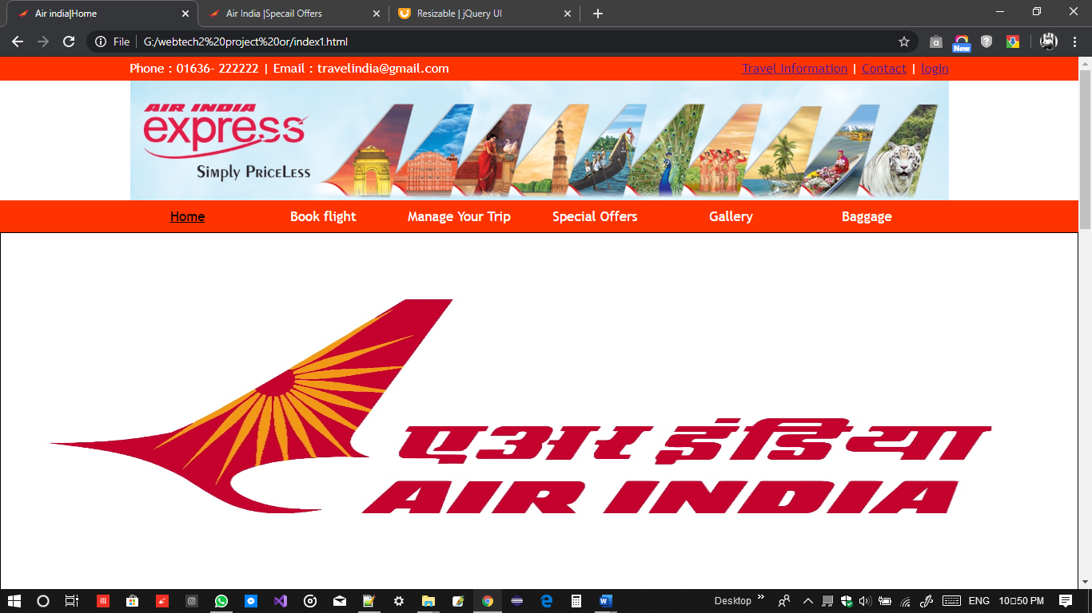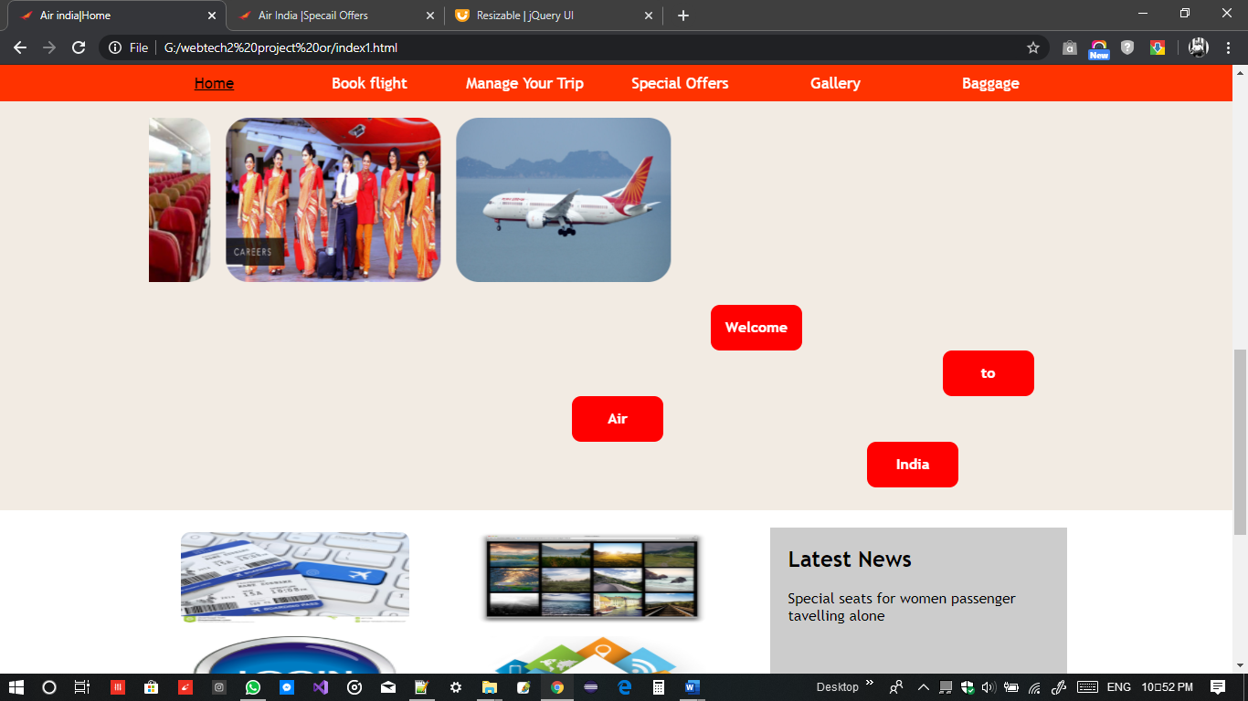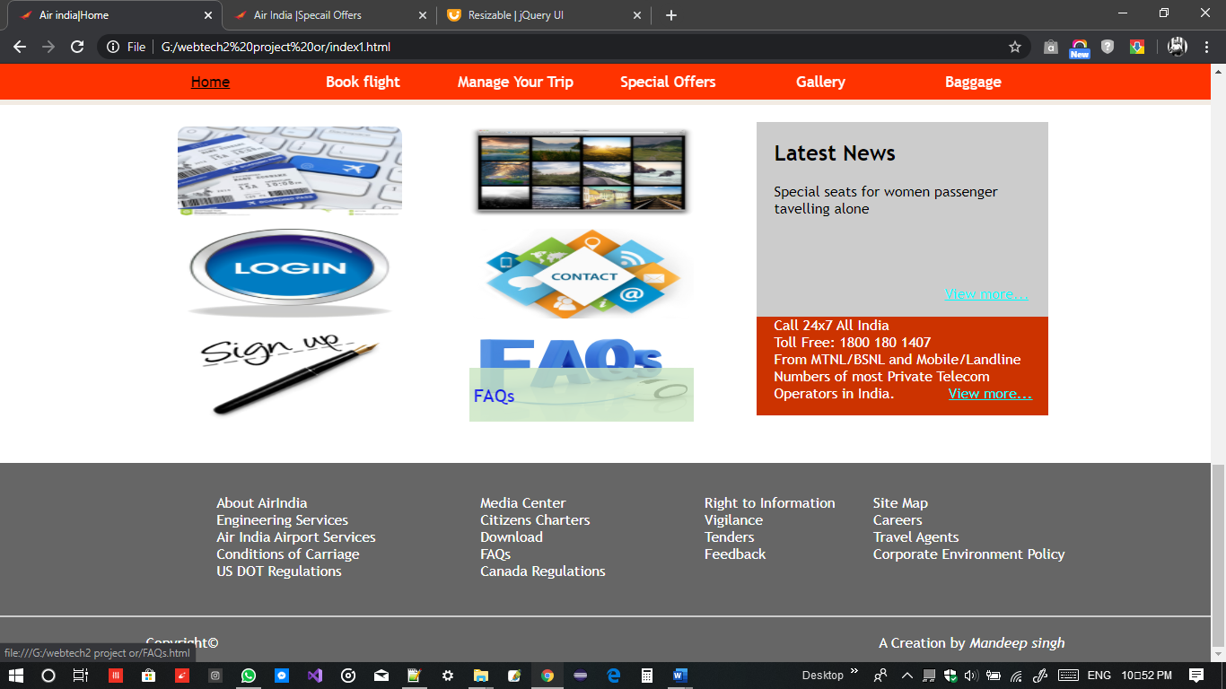
2. Book Flight

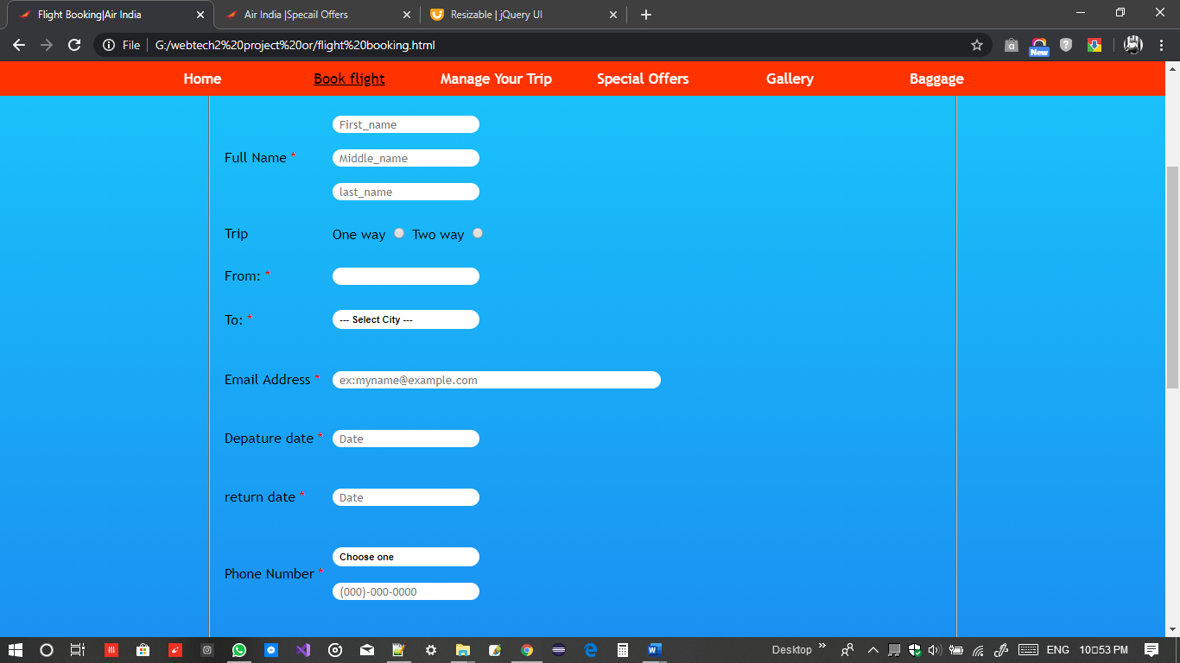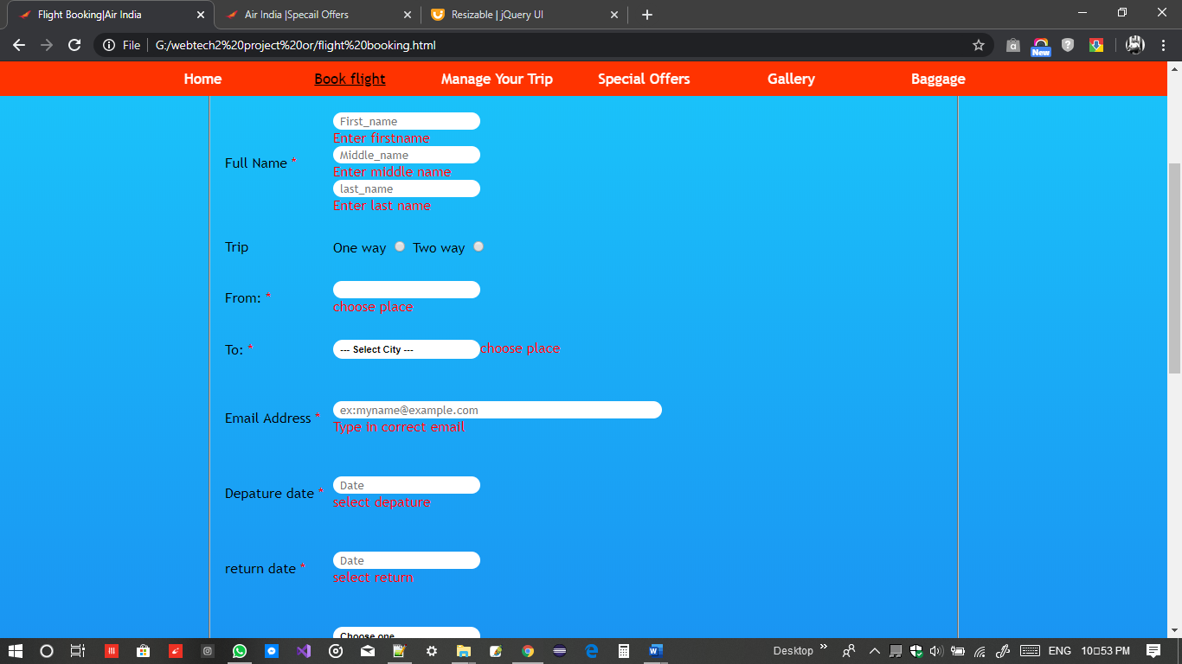

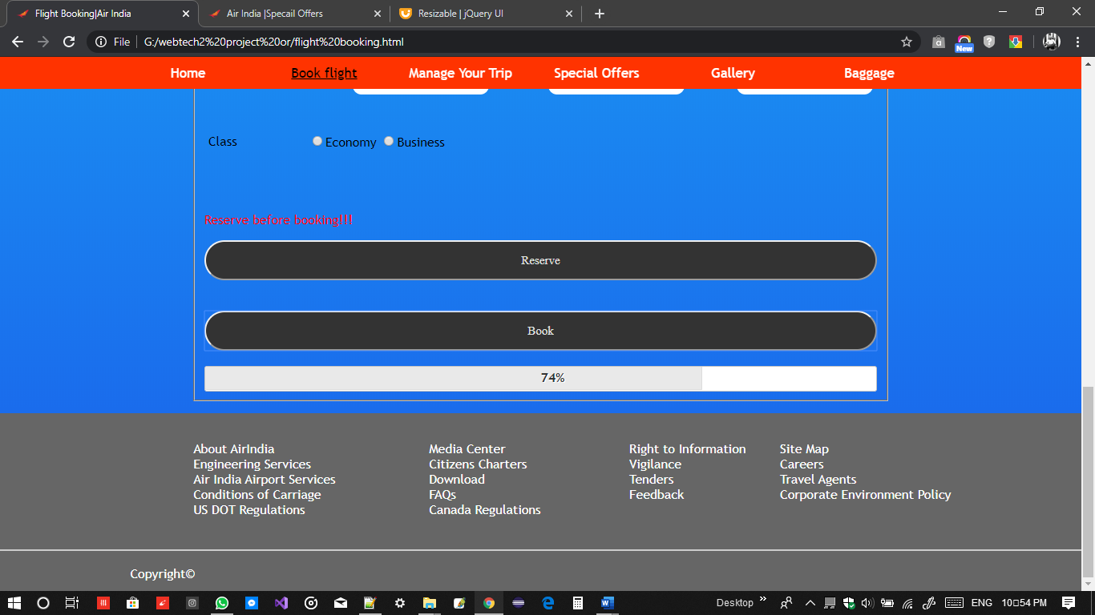

3. Manage.html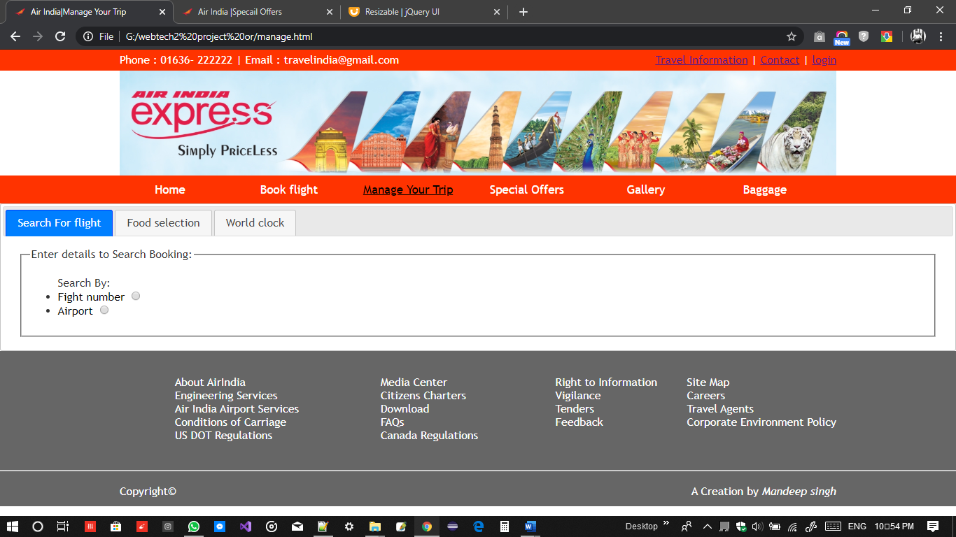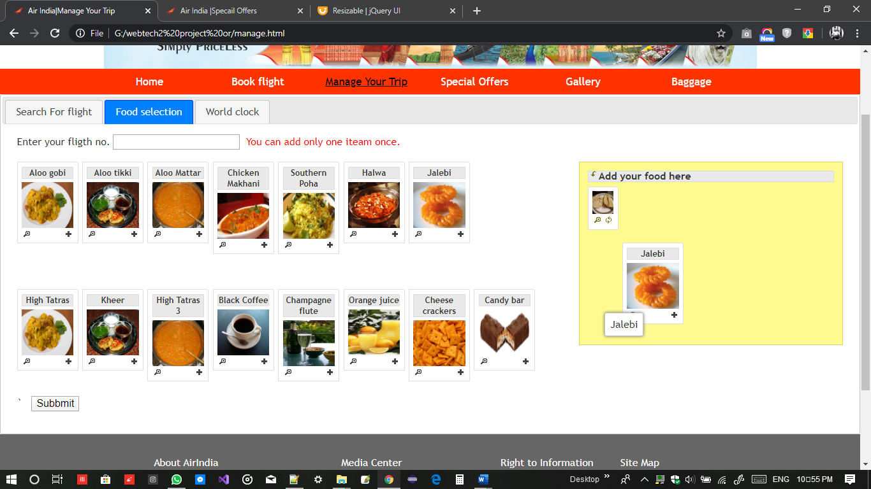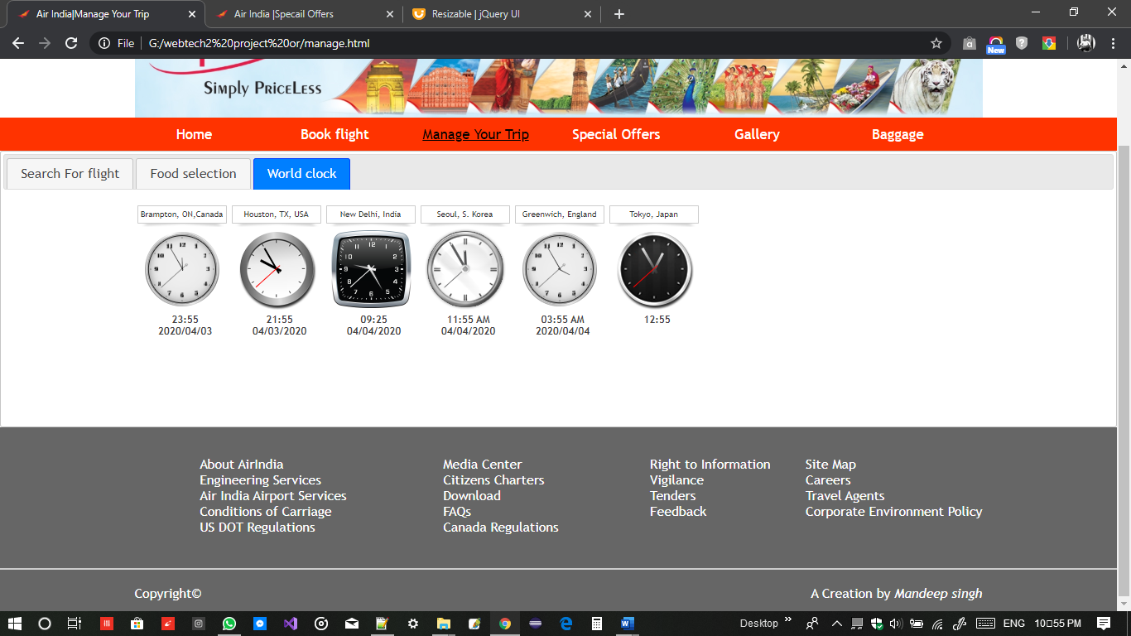

4. Specailoffer.html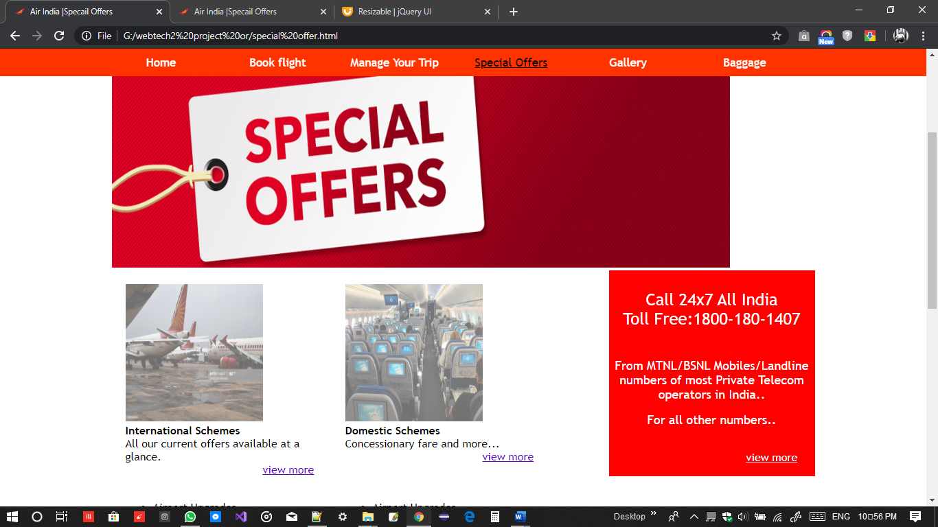

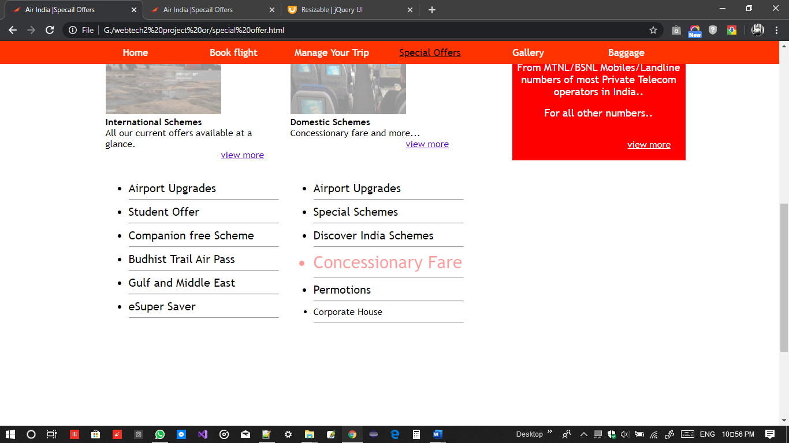

5. Gallery.html

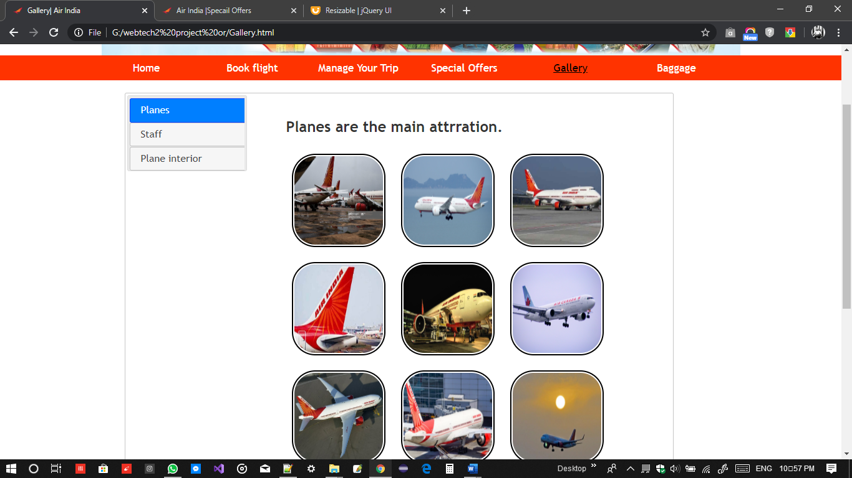

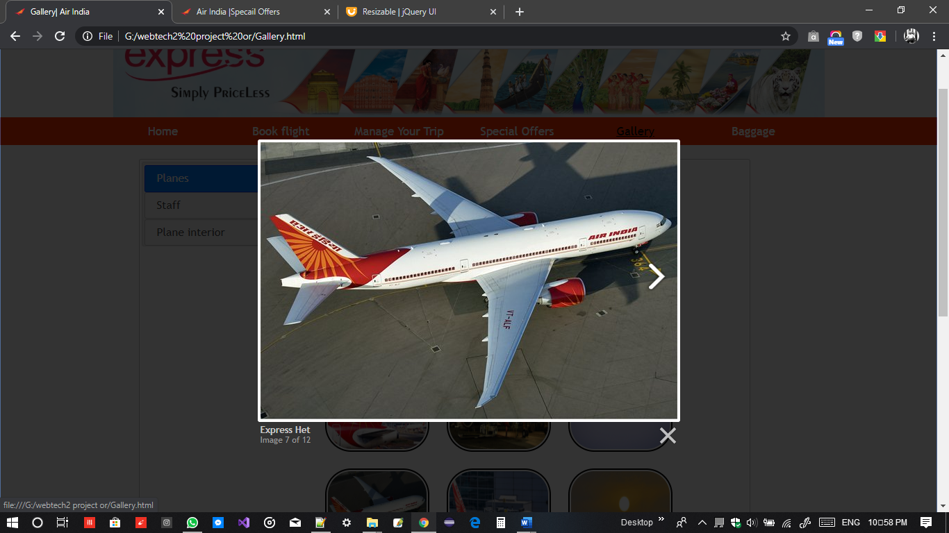

6.Baggage.html

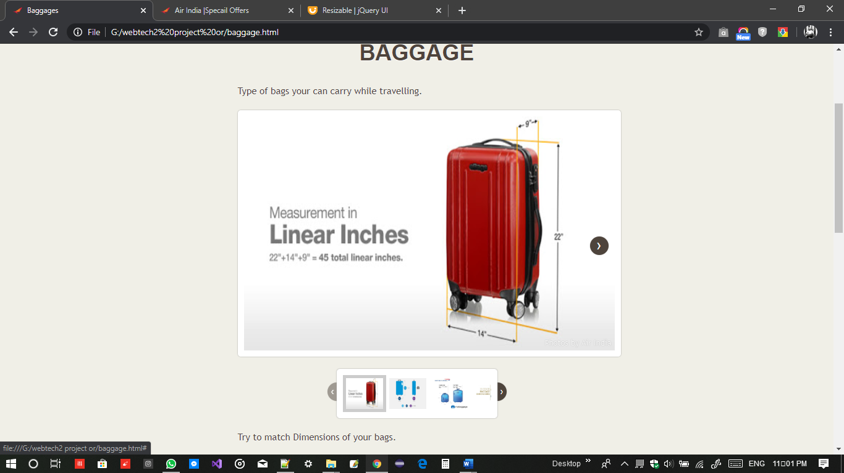

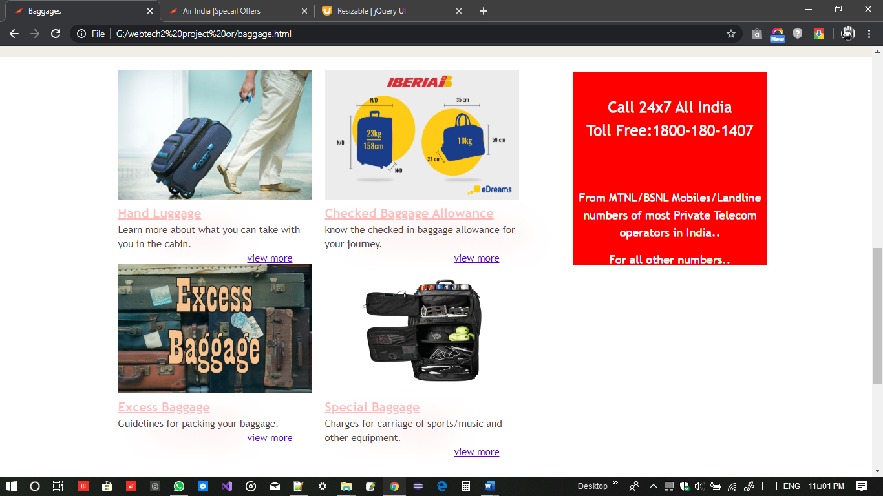

7. login.html

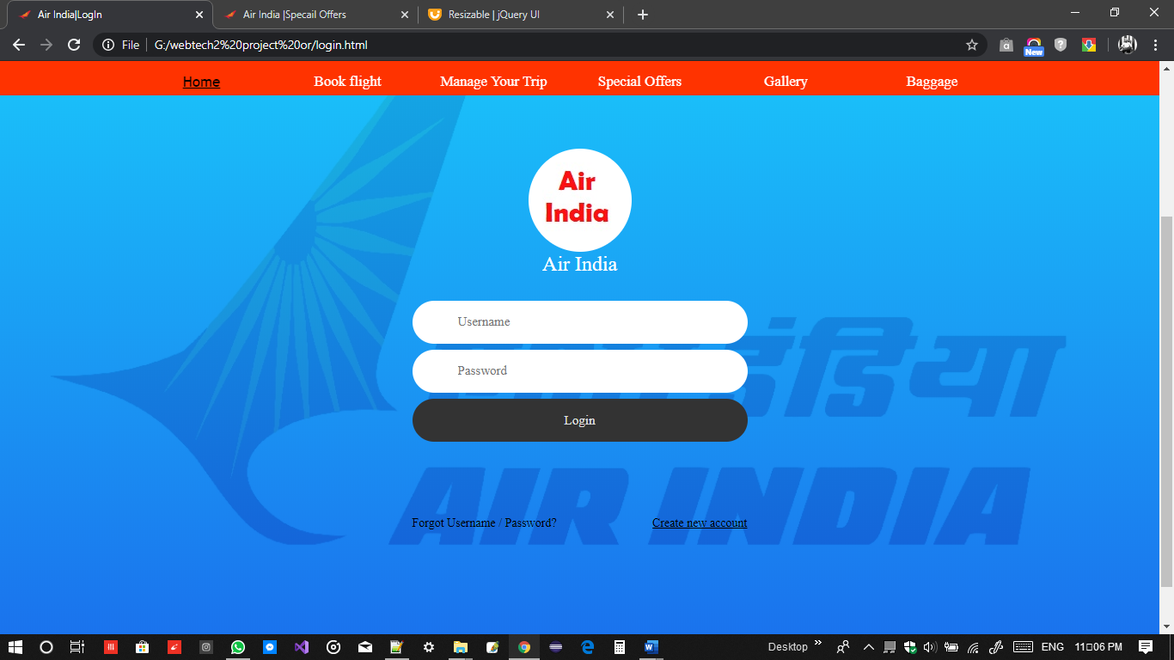

8. signup.html

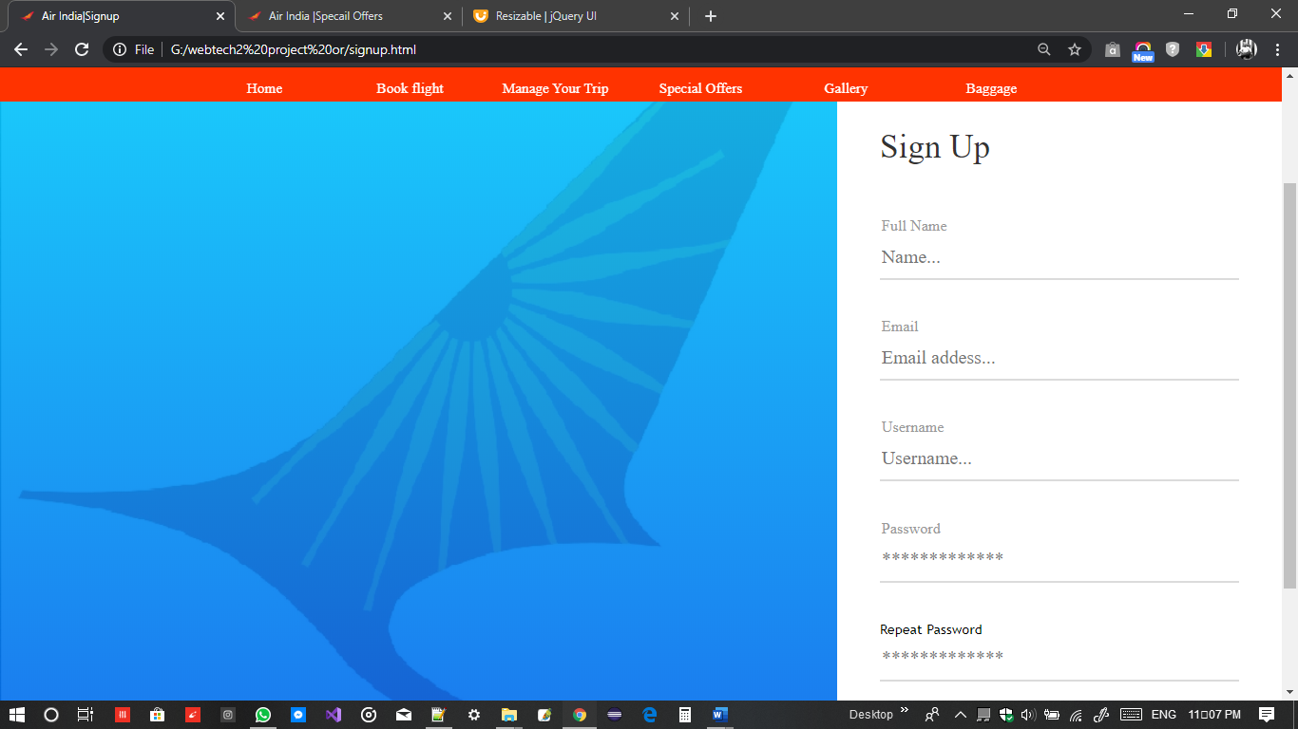

9. Travelling. Html (travel information)

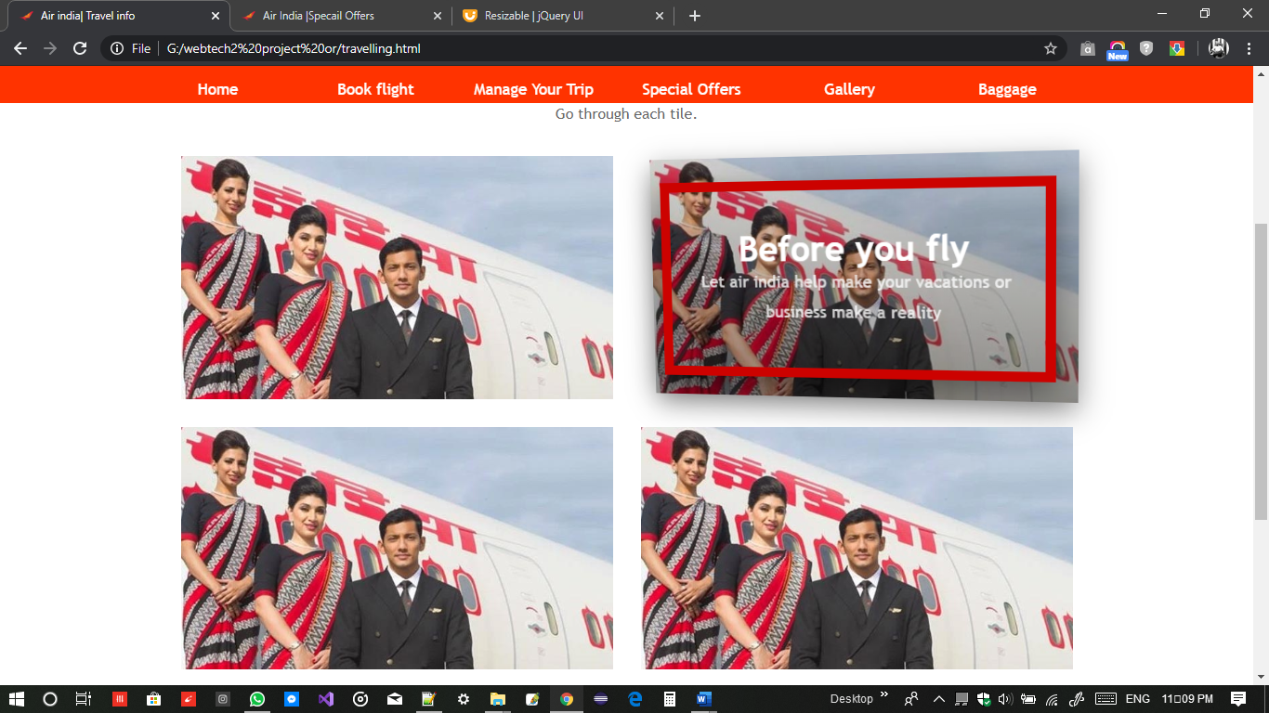

10.Feedback.html

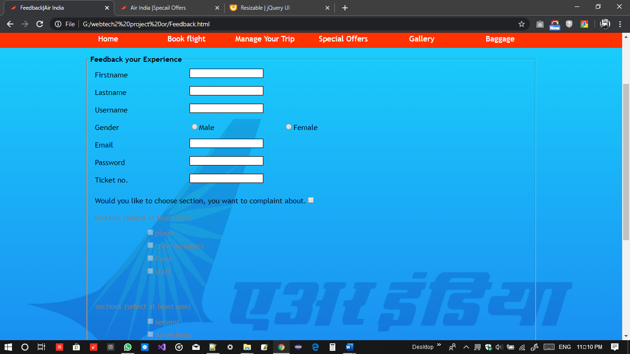

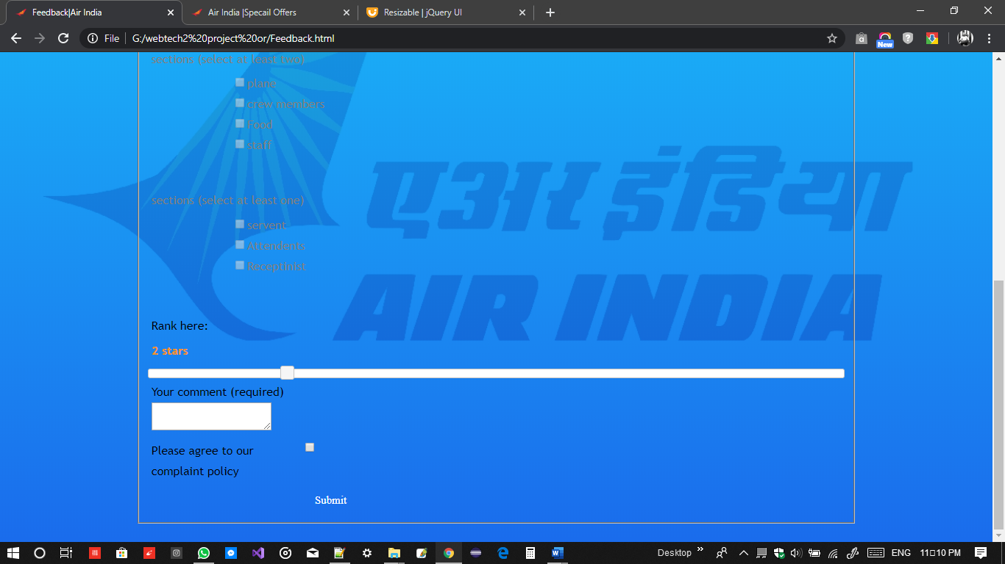

11. FAQs(in footer)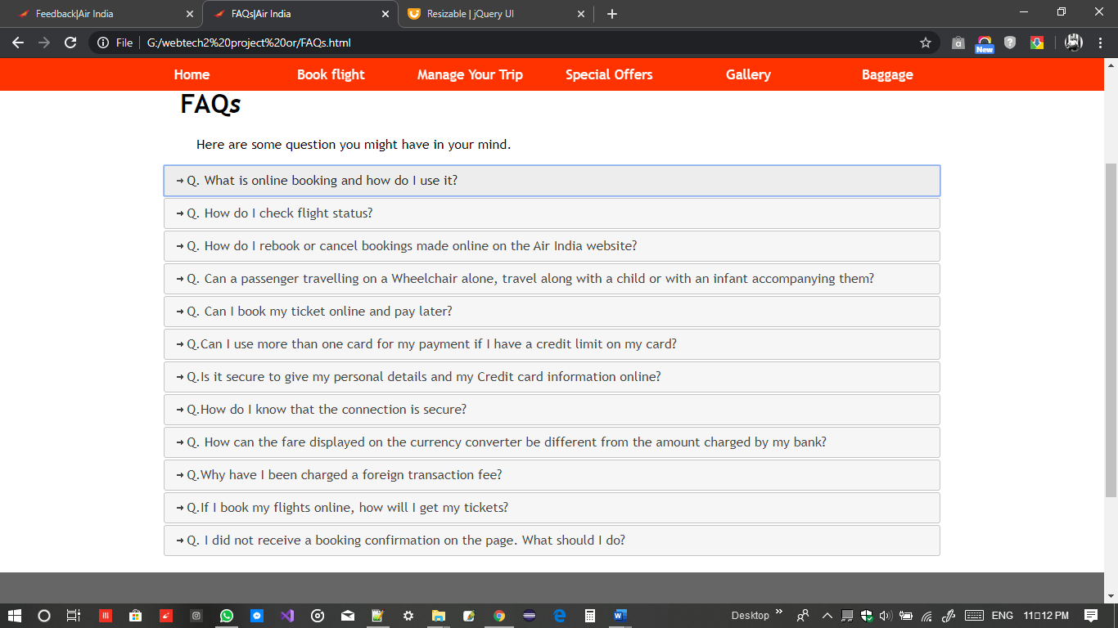

12. Right to inforamtion (in footer)

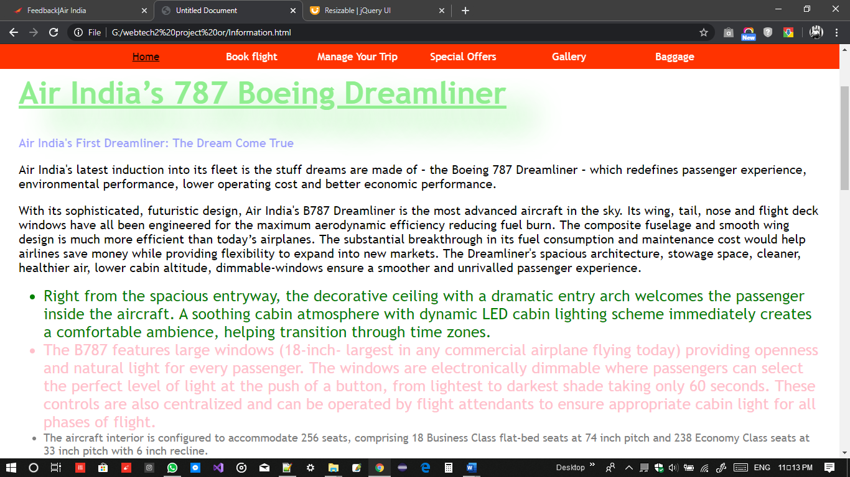

13. contact.html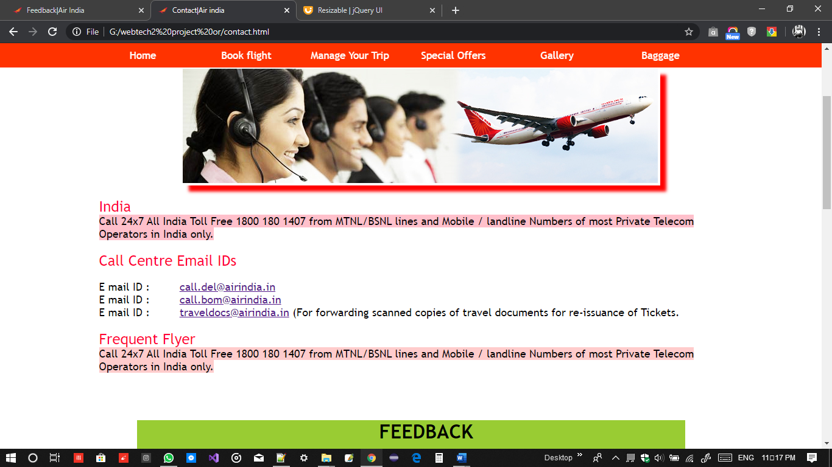

## Mobile View

|  |
| --- |
| 1. Login page mobile page      1. Sign up      1. About me      1. Swipe left      1. Right Swipe |

# Extra Features implemented

|  |
| --- |
| All pages consist of Logo on bars in browsers along with page description |
| All pages have top floating navigation bar. It starts to float after it touches top. |
| CSS animation with keyframes in index1 page. |
|  |
|  |